Azure Container Registry:

Login the portal.azure.com and provide credentials

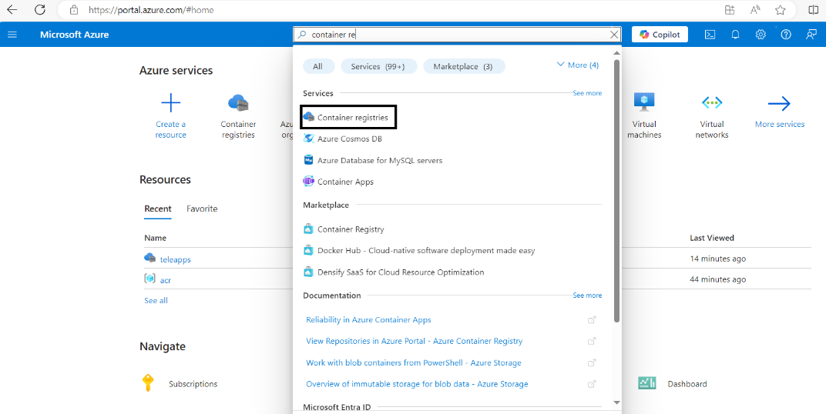

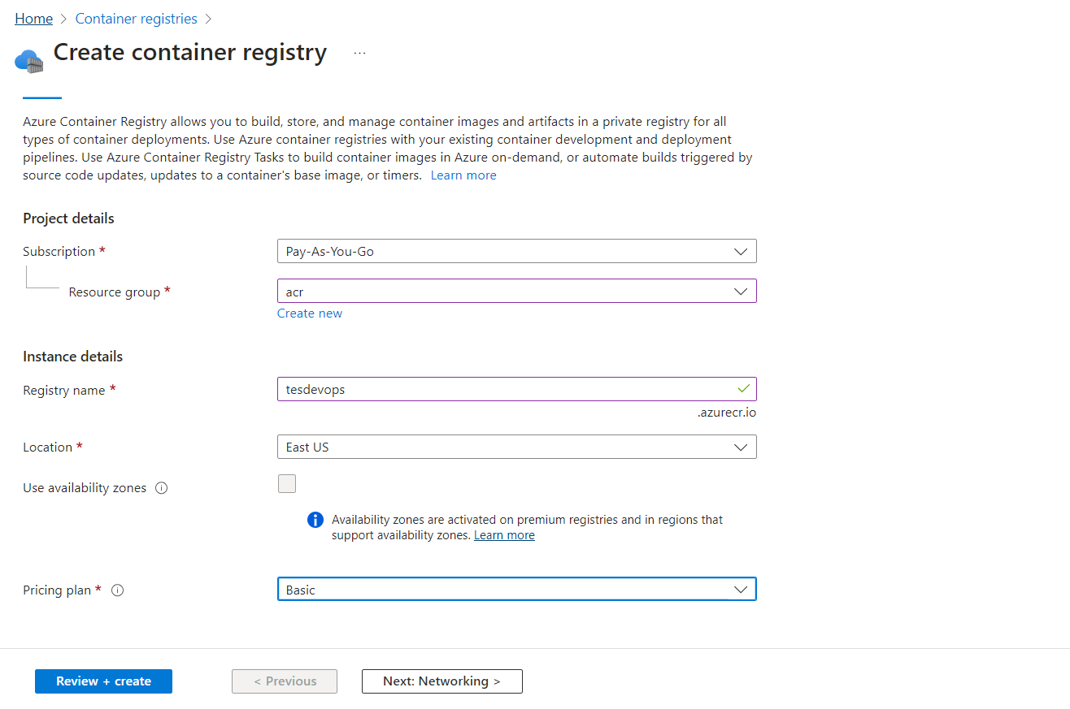

Click review and create

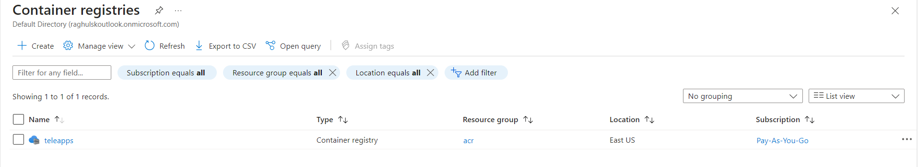

Then click teleapps

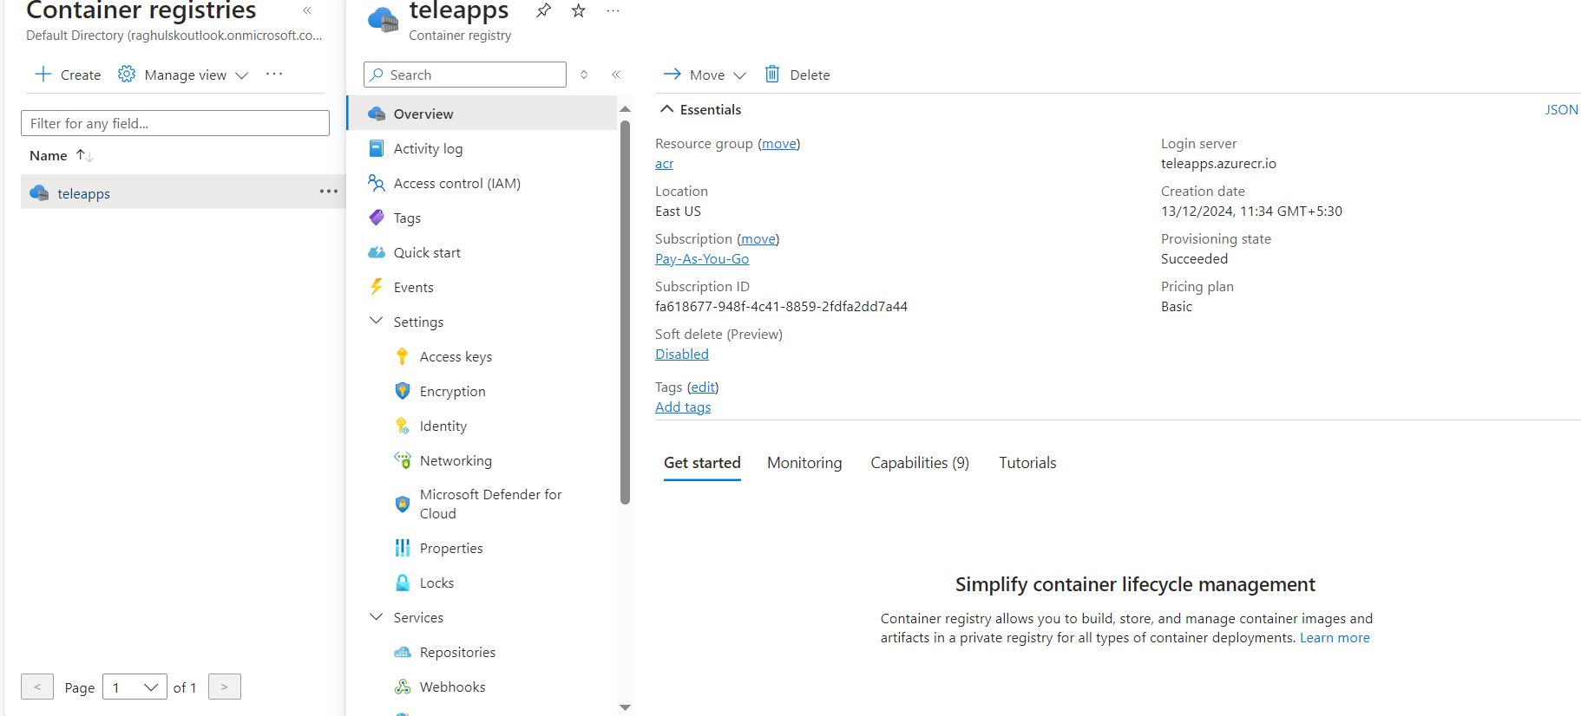

Create registry username and password use teleapps🡪settings🡪Access Keys

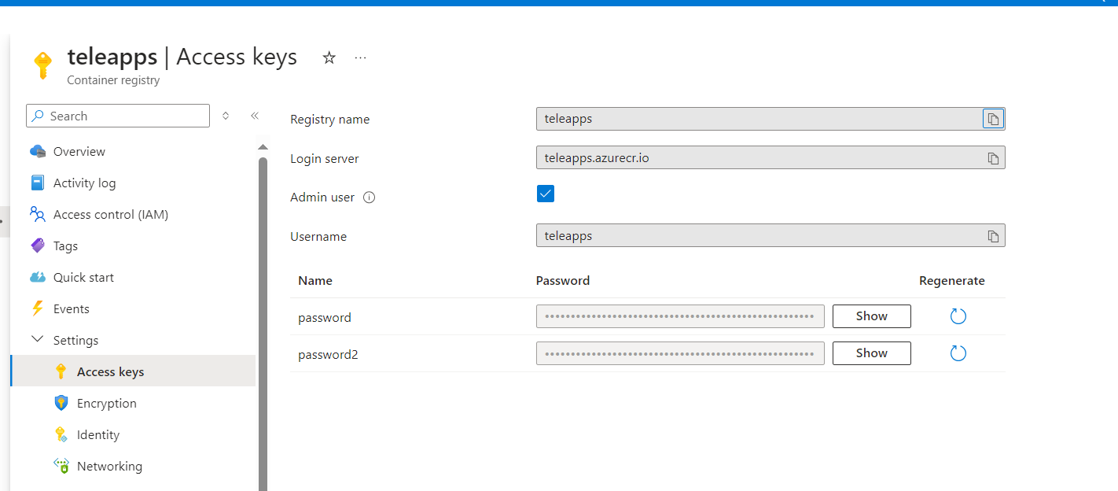

Then go to Linux server:

Install azure cli in linux server

#sudo apt-get update

#sudo apt-get install apt-transport-https ca-certificates curl gnupg lsb-release

#sudo mkdir -p /etc/apt/keyrings

#curl -sLS https://packages.microsoft.com/keys/microsoft.asc |

gpg --dearmor | sudo tee /etc/apt/keyrings/microsoft.gpg > /dev/null

#sudo chmod go+r /etc/apt/keyrings/microsoft.gpg

#AZ_DIST=$(lsb_release -cs)

echo "Types: deb

URIs: https://packages.microsoft.com/repos/azure-cli/

Suites: ${AZ_DIST}

Components: main

Architectures: $(dpkg --print-architecture)

Signed-by: /etc/apt/keyrings/microsoft.gpg" | sudo tee /etc/apt/sources.list.d/azure-cli.sources

#sudo apt-get update

#sudo apt-get install azure-cli

#az login --use-device-code



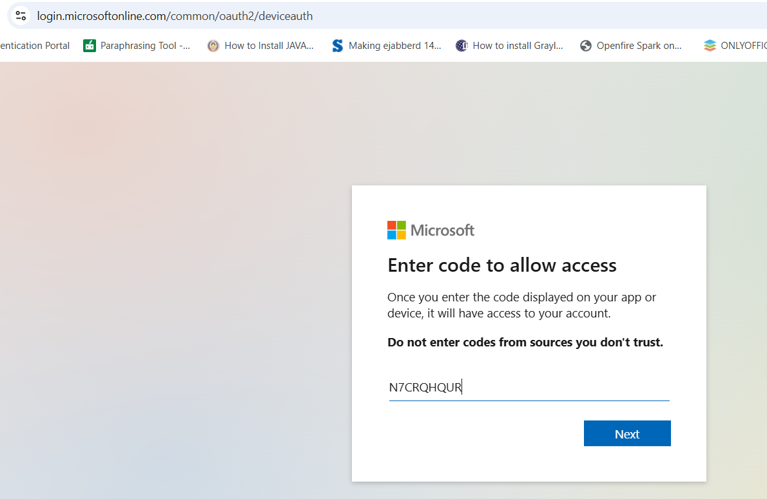

Then authorize the code through Microsoft portal

Then authorized azure container registry through az cli

teleapps🡪settings🡪Access Keys



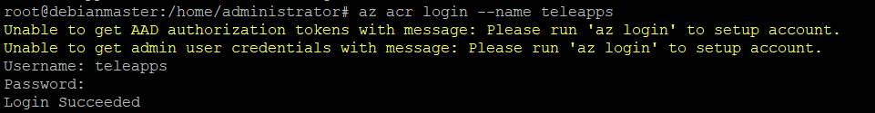

Push docker image to azure container registery

#docker tag baseimage teleapps.azurecr.io/baseimage:latest

#docker push teleapps.azurecr.io/baseimage:latest

